**MINI PROJECT**

Create a To Do List in Python

In this Python project, we will build a To Do List using the File I/O. It is a beginner-level python project, and you should have basic knowledge of file I/O before you begin and you will be able to apply them in real life. Let’s get started!

### **About To-Do Lists**

To-Do Lists are actually a list of your daily tasks that you keep on your person to remind yourself of the tasks you have to accomplish that day. In this project, we are going to make a python to-do list with options to add and delete items in your list.

**Source code for To-D0 List in python:**

1.Initializing the variables and Building Function:

# Define an empty list to store tasks

tasks = []

# Function to display the to-do list

def display_tasks():

if not tasks:

print("No tasks in the to-do list.")

else:

print("To-Do List:")

for index, task in enumerate(tasks, start=1):

print(f"{index}. {task}")

2. Creating function to add a task to the To-Do List:

# Function to add a task to the to-do list

def add_task(task):

tasks.append(task)

print(f"Task '{task}' added to the to-do list.")

3. Creating function to delete a task from the To-Do -List:

# Function to delete a task from the to-do list

def delete_task(index):

if 1 <= index <= len(tasks):

delete_task = tasks.pop(index - 1)

print(f"Task '{delete_task}' removed from the to-do list.")

else:

print("Invalid index. Please provide a valid index.")

4.Creating function to mark task as Completed:

# function to mark task as completed

def complete_task(index):

if 1<= index <=len(index):

completed_task=todo_list.pop(index-1)

print(f"Task{completed_task}'marked as completed.")

else:

print("Invalid index.please enter valid task.")

# Main function to run the to-do list app

def main():

while True:

print("\n1. Display To-Do List")

print("2. Add Task")

print("3. Delete task")

print("4.complete task")

print("5. Quit")

choice = input("Enter your choice (1/2/3/4): ")

if choice == '1':

display_tasks()

elif choice == '2':

task = input("Enter the task: ")

add_task(task)

elif choice == '3':

index = int(input("Enter the index of the task to remove: "))

delete_task(index)

elif choice == '4':

print("Exiting the to-do list app. Goodbye!")

break

else:

print("Invalid choice. Please enter a valid option.")

if __name__ == "__main__":

main()

OUTPUT:

#Adding a task

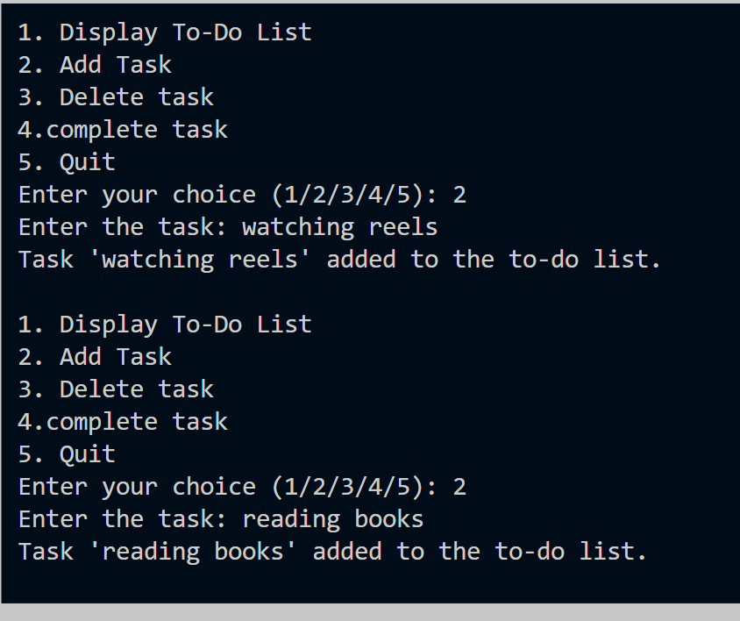

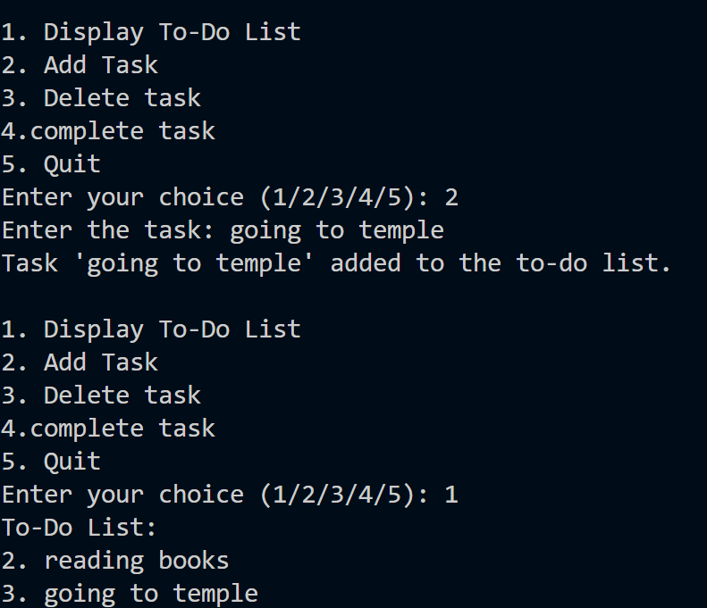

# Deleting the task and complete task

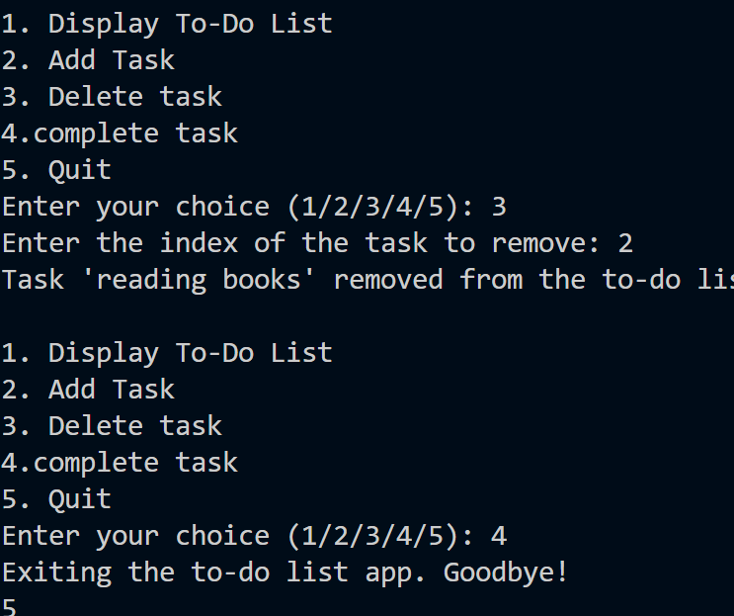

Conclusion:

Here, we Conclude that we create a To-Do-List project using python. Check the link below:

Link: <https://colab.research.google.com/drive/1uZpQzCcTC5Hf4q09JTZMnTSYR2j6DeZb?authuser=0#scrollTo=vA5gU1Pfr2IQ>

Submission:

This Mini project “To-D0-List” using python is submitted by

PAMANJI VISALAKSHI.